Requirement Analysis

Document history

|  |  |  |  |  |
| --- | --- | --- | --- | --- |
| Version | Date | Author | Changes | Valid from |
| 1.0 | 19-Jul-2016 | Changming Wu | Draft | 19-Jul-2016 |

Table of Contents

1 Introduction 3

1.1 Purpose of the system 3

1.2 Scope of the system 3

1.3 Core System Functionalities 4

1.4 Objectives and Success Criteria of the Project 11

2 Current System 11

3 Proposed System 12

3.1 Overview 12

3.2 Functional Requirements 12

3.3 Non-functional Requirements 13

3.3.1 Usability 13

3.3.2 Reliability 13

3.3.3 Performance 13

3.3.4 Supportability 14

3.3.5 Implementation 14

# Introduction

## Purpose of the system

Secure and efficient database implementation with suggested best practice is one of the challenge for an organization and as well as an important part of the duty for a database administrator,

1. Database authentication and network communication port need to be considered after database installation and essential to check especially in production environment to overcome the safety loopholes by changing default database port and default system users access in database.
2. There are critical default installation options include drive and database physical structure selections which are not easy to change after the database is hosted.
3. Old database installation software version is also considered to raise a concern for database performance and security.

4. Other things to consider are memory, CPU, database recovery model and compatibility level parameters which all affect database performance if they are not tuned.

Identifying details of SQL Server configurations is a time consuming process and lots of manual work for a new database administrator who wants to know the configured parameters values of all SQL Server instances and for all databases without well maintained inventory.

Sometimes it is very difficult for a database administrator to check and create an inventory of all the database parameters especially for large SQL Server environment. Maintaining the databases accordance to best practice will also become challenging when organisation has so many databases.

## Scope of the system

A database evaluator that will diagnose and check the basic implementation parameters of SQL Server Instances and Databases. The database evaluator will target all versions of SQL Server starting with SQL Server 2008 and SQL Server 2012. Older versions of SQL server will not be supported.

1. A website from where a customer can download the client application and upload the database dump files.

1. A client application that will produce a dump file of the existing client’s database and SQL instance parameters values only.

3. A database evaluator tool that will generate reports from the dump files uploaded by customers.

It is planned that these dump files will be encrypted for security purposes. The client application is free to download from the product website and profit will be generated instead when customers choose to avail of the database evaluation services.

## Core System Functionalities

* Website

Customer can download a client application from website. Installation guide and instruction are available on the website.

The website will allow customer to upload the encrypted files after they have successfully logged in to their account.

* Client Application

A client application is a light weight and small tool which will be executed on a customer database system and gather the existing configured values for parameters and captures the encrypted files.

The following areas of database from where parameters values will be collected by client application.

* Database Evaluator

Parameters in encrypted file will be diagnosed with another application called Database Evaluator. Database Evaluator will check all the parameter against the best practice values and generate the final report. A small database will be created for database evaluator application which store all the best practice values and information about latest service pack for SQL server. This database is manage and update by project team.

The final report will display all information about what parameters are not configured and suggest and what will be the parameter values as per suggested best practice.

The customer can download their final report from the website.

## Objectives and Success Criteria of the Project

The success of the project depends upon meeting the following core set of objectives

1. A functional website with ability to download the client application.
2. Website can also work as FTP to upload dump file and download the final report.
3. Basic installation procedure are available on website.
4. Customer create their account to upload dump file and download the final report
5. Client application is small and light weight application which will be executed by customer on their database system and application generated encrypted dump file which contains all the agreed database and SQL instance parameter values.
6. Database Evaluator (DBE) is able to generate the final report after check all the parameters from dump file.

# Current System

No system is in place at the moment with the same functionality.

# Proposed System

## Overview

This section provides a functional overview of the system. This will again be properly be divided into two parts.

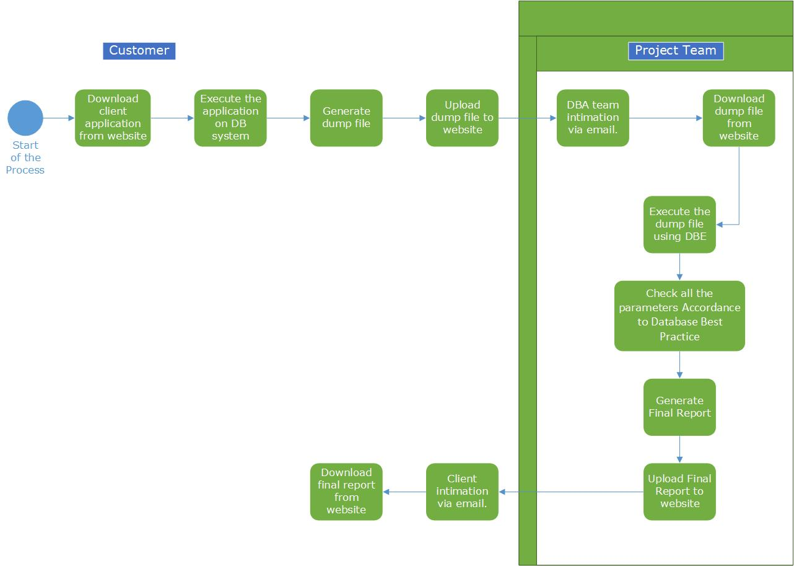

## Functional Requirements

* Customer must be able to download the client application and install on customer database system.
* Client application must be able to generate the encrypted dump file with all required parameter values.
* Customer must be able to select server name and able to connect the SQL Server instance by clicking on connect button.
* Customer must have option to select any single database if he want to evaluate.
* Customer must be able to see the progress of execution.
* Customer must be able to create their own account on website.
* Customer must have basic help and installation procedure available on website.
* Customer must be able to upload the dump file and download the final report from their account.
* Customer must have valid email address.
* Website must be able to send the required notifications.

## Non-functional Requirements

### 3.3.1 Usability

* Client application and database evaluator must be run on windows environment only and used by customer.
* Website is platform independent, must be supported all widely used web browser and used by customer and project team.
* “About” and “Help” information about the product must be able to be retrieved at any point during the run of application.
* Customer must be able to choose the server name from a list. Green mark must be there to indicate that connection is successful.
* Customer see the progress on execution for client application.
* Client application must be downloaded from website.
* Client and project team must be notify while uploading the dump file and final report.

### 3.3.2 Reliability

* Components of the project will be tested alongside the implementation phase to ensure that they are functional.
* Final, integrated project Code will be tested to ensure that greater than or equal to 80% of the integrated code is covered at run-time, and is functioning properly.

### 3.3.3 Performance

* Client application collects the parameter values without any error and modifying existing values.
* Encrypted dump file will be uploaded on website without any error.
* Database Evaluator will check and produce the final report without any errors.

### 3.3.4 Supportability

* The client application is platform dependent as it should be able to run on platform supporting .net framework only.
* Client application and database evaluator support the SQL Server 2008 R2 and SQL Server 2012.
* Website is compatible to run with all popular web browser.
* Database evaluator is also platform dependent as it should be able to run on platform supporting .net framework only.

### 3.3.5 Implementation

* Client application and database evaluator will be developed in C#.
* SQL Server 2008 R2 and SQL Server 2012 will be used for creating database, generate and test SQL script.
* Website will be created using a Wordpress and MySQL.